CASE STUDY 7: AUTOMATED MCQ EVALUATION AND SCORING SYSTEM
MULTIPLE-CHOICE QUESTION (MCQ) GRADING AND RANK LIST GENERATION
1 PROBLEM STATEMENT
Design and implement an automated objective assessment utility that compares student multiple-choice question responses against a master answer key, applies negative marking rules and unanswered penalties, calculates final scores, and generates a sorted performance rank list.
2 OBJECTIVES
- Define master answer keys and customizable marking weights (correct answers, wrong penalties, and unanswered items).
- Evaluate student answer strings character-by-character, handling missing responses or blank spaces gracefully.
- Compute comprehensive scorecards comprising correct counts, incorrect counts, unanswered counts, and net weighted scores.
- Aggregate results and generate an official rank list sorted by descending final scores.
3 KEY ASSUMPTIONS
Answer keys and student submissions are standardized string sequences. Unanswered or truncated responses are designated using dashes (-) or spaces. Marking weights remain uniform across all questions for a given test session.
4 ALGORITHM
- Initialize the master ANSWER_KEY and scoring constants (MARKS_CORRECT, MARKS_WRONG, MARKS_UNANSWERED).
- For each student, iterate through the question indices up to the length of the answer key.
- Classify each response: if missing or blank, count as unanswered; if matching the key, count as correct; otherwise, count as incorrect.
- Calculate the net score using the weighted formula: $\left(\text{correct}×\text{MARKS_CORRECT}\right)+\left(\text{incorrect}×\text{MARKS_WRONG}\right)+\left(\text{unanswered}×\text{MARKS_UNANSWERED}\right)$.
- Sort all student evaluations in descending order of final scores to generate the final rank list.
5 FLOWCHART REPRESENTATION
Plaintext
[Start] -> [Read Answer Key & Student Submissions] -> [Iterate & Compare Responses]
-> [Response == '-' or ' '? Yes: Unanswered++ | Match Key? Yes: Correct++ | Else: Incorrect++]
-> [Calculate Net Score = (Correct * 4) + (Incorrect * -1)]
-> [Sort Results by Score Descending] -> [Display Scorecard & Rank List] -> [End]
6 PSEUDOCODE
Plaintext
FUNCTION evaluate(answer_key, student_answers):
correct = 0, incorrect = 0, unanswered = 0
FOR i FROM 0 TO LENGTH(answer_key) - 1:
given = student_answers[i] IF i < LENGTH(student_answers) ELSE "-"
IF given == "-" OR given == " ":
unanswered += 1
ELSE IF given == answer_key[i]:
correct += 1
ELSE:
incorrect += 1
score = (correct * MARKS_CORRECT) + (incorrect * MARKS_WRONG) + (unanswered * MARKS_UNANSWERED)
RETURN correct, incorrect, unanswered, score

SORT results BY score DESCENDING
PRINT formatted scorecard and ranked list
8 TEST CASES
Student Name | Submission String | Evaluated Breakdown | Net Score & Rank
Ravi | ABCDABCDAB | 10 Correct, 0 Wrong, 0 Unanswered | Score: 40 (Rank 1)
Sita | ABCD-BCD-B | 8 Correct, 0 Wrong, 2 Unanswered | Score: 32 (Rank 2)
Meena | AB-D-B-DAB | 6 Correct, 0 Wrong, 4 Unanswered | Score: 24 (Rank 4)
9 OUTPUT SCREENSHOTS
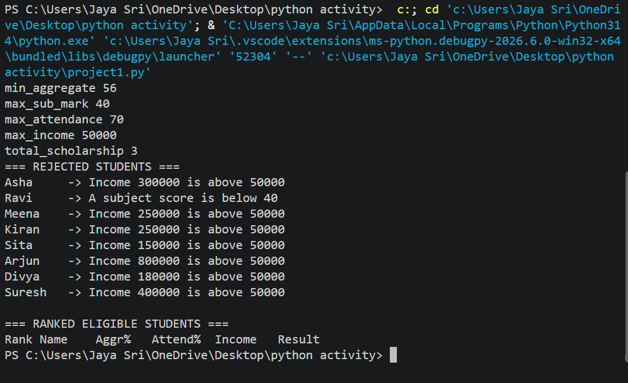

10 CONCLUSION
The automated MCQ evaluation module efficiently processes bulk student responses, enforces negative marking policies accurately, and generates structured leaderboards for transparent academic assessment.

